**Welcome to LazyWire!**

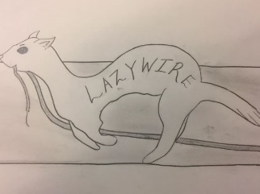

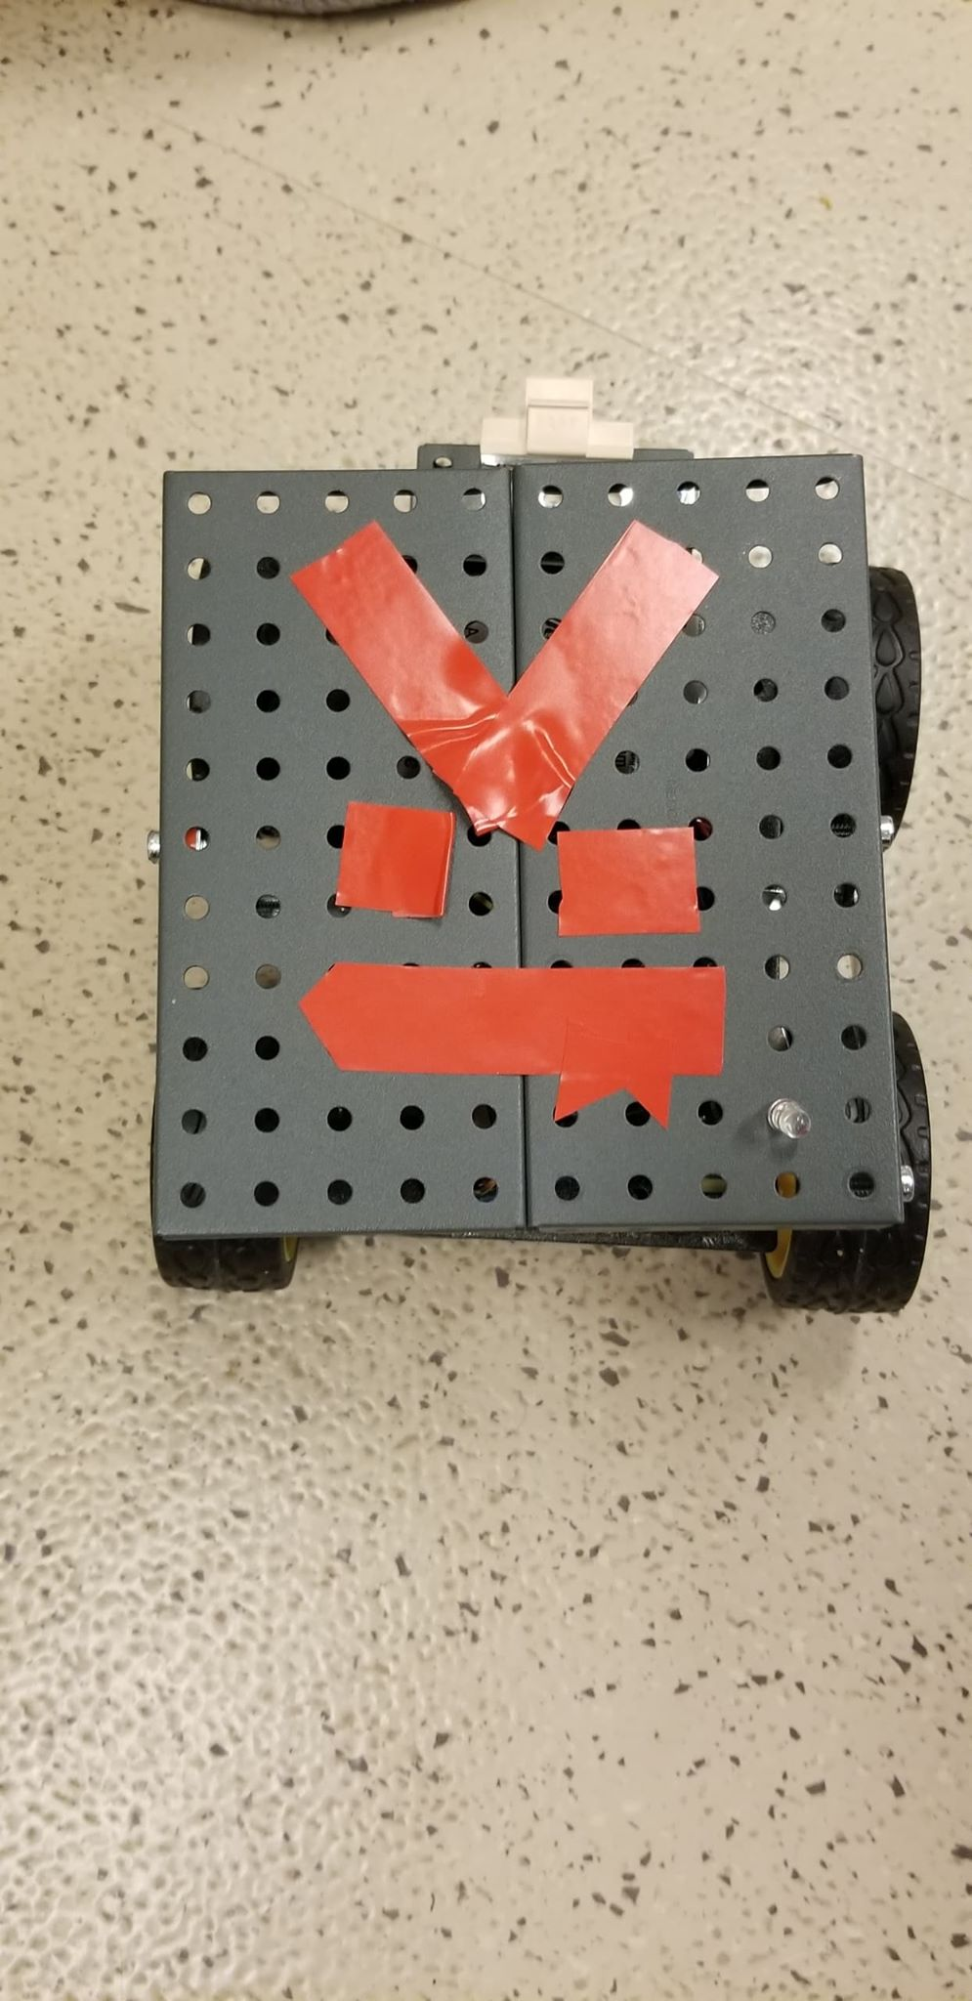

**Here’s Our Journey, Told By Pictures!**

**Deciding Which Microcontroller To Use...**

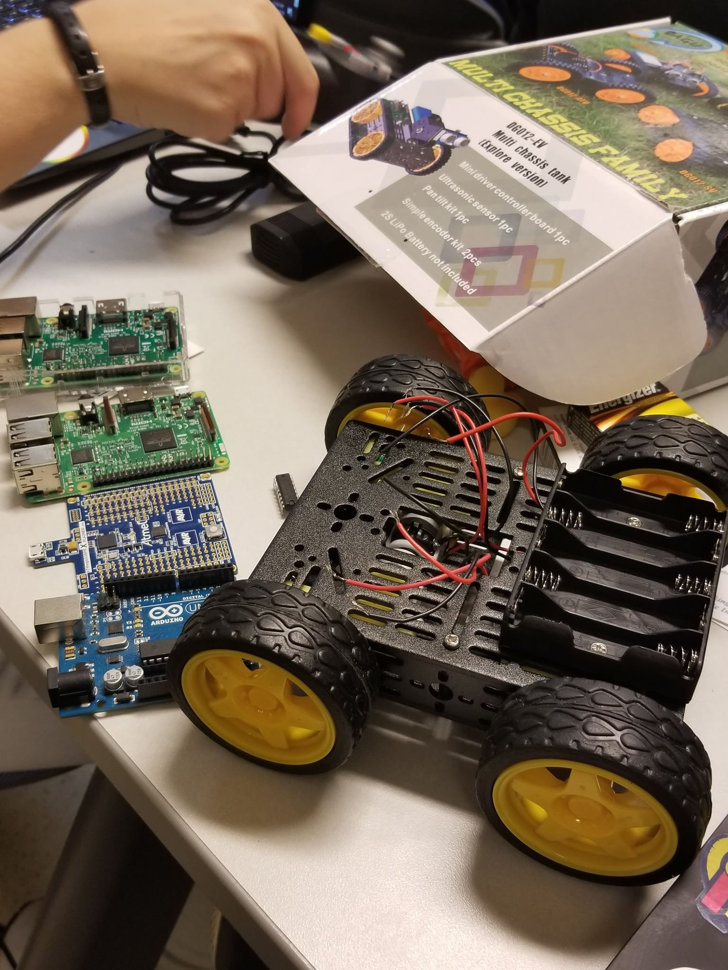

**Sir Quakesalot Tells Us To Use The Arduino Uno**

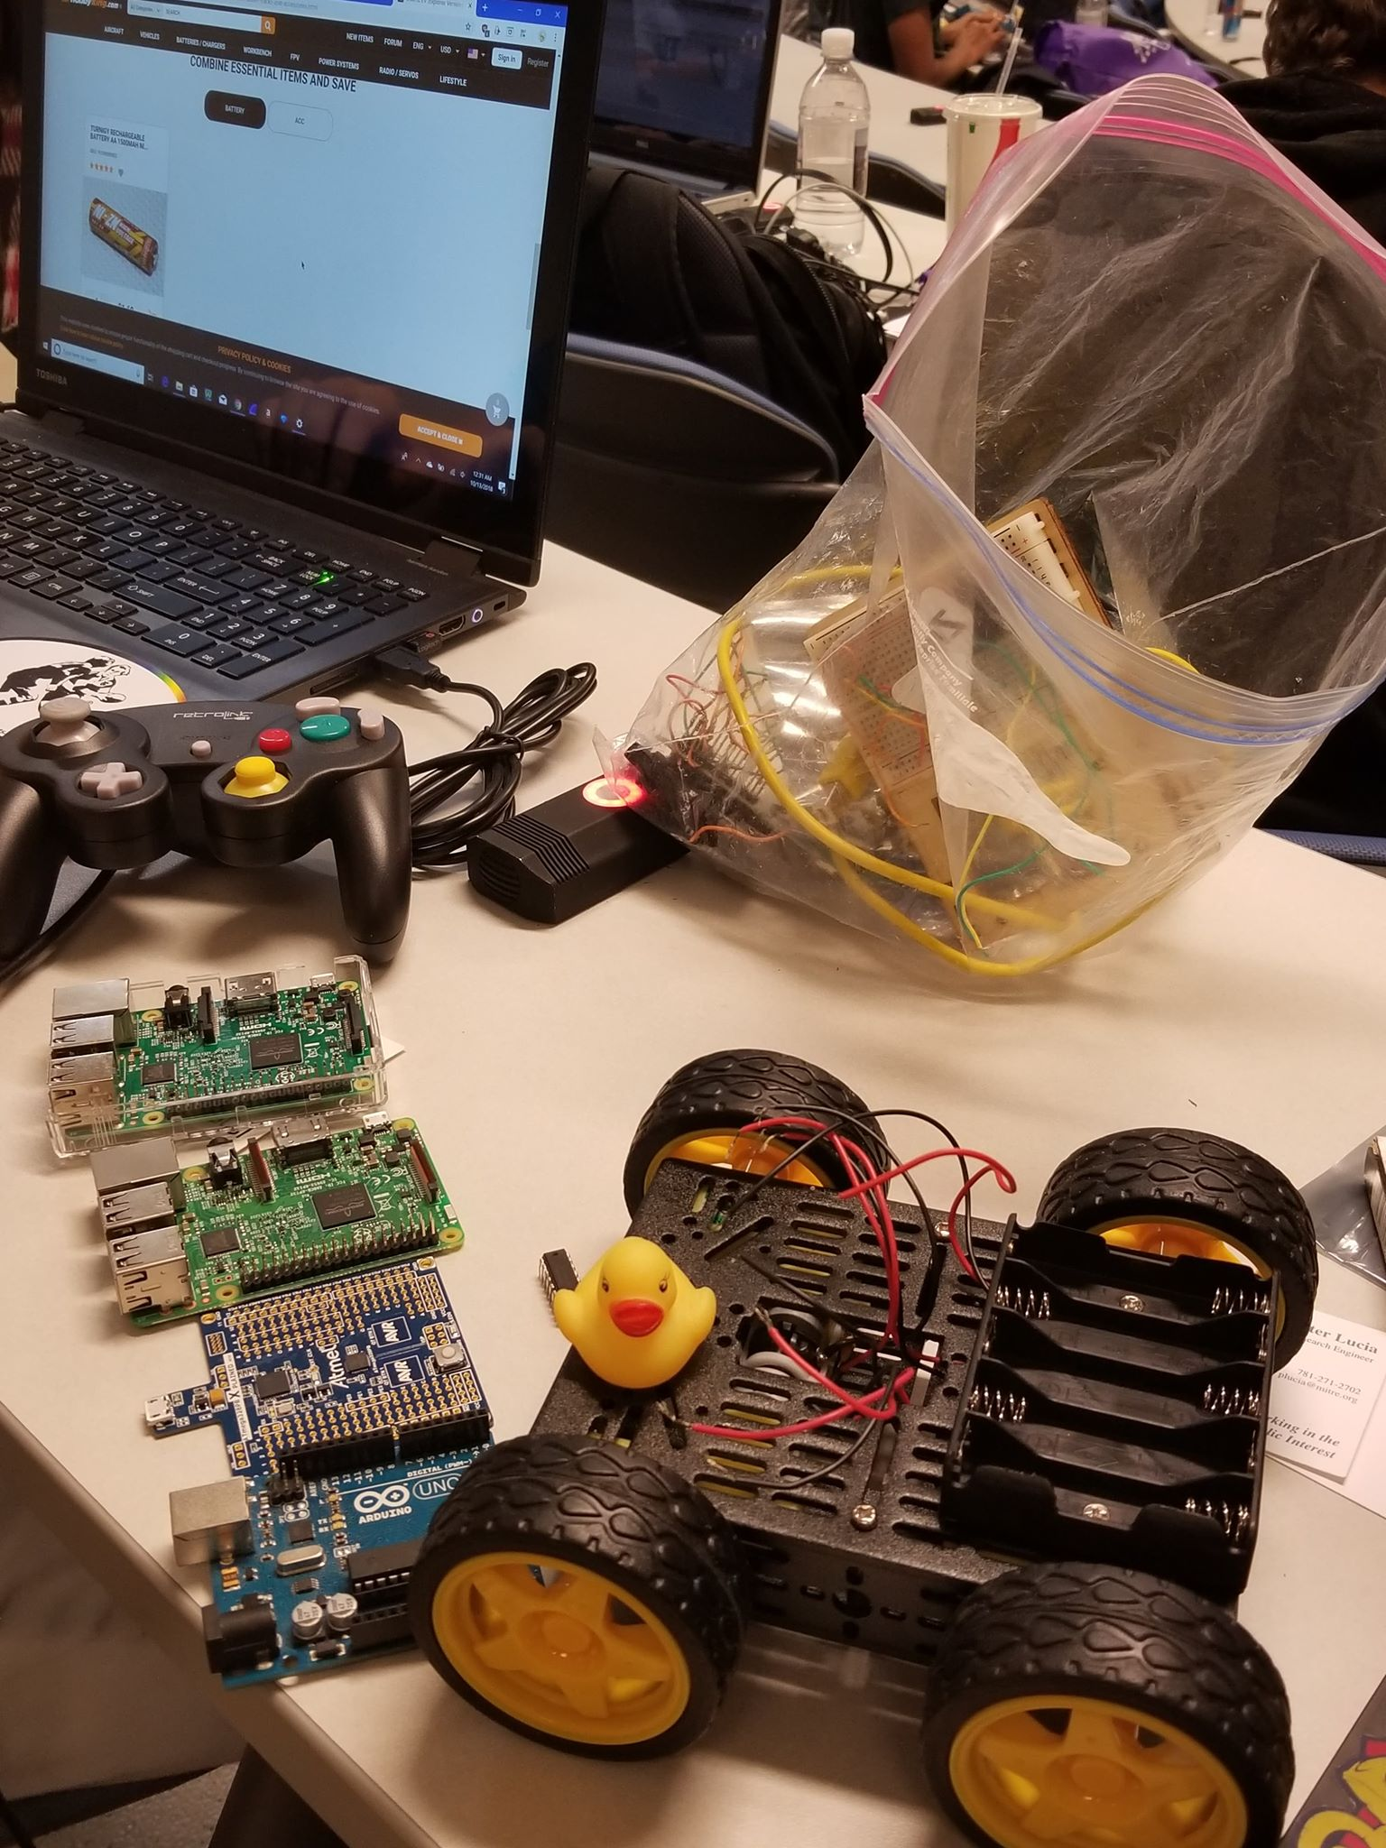

**The Trials Of Wiring!**

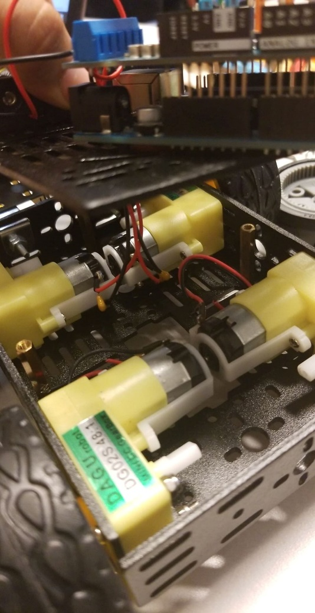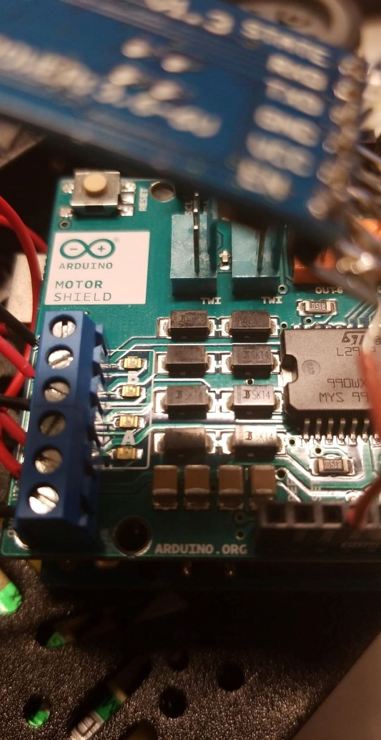

**Introducing The Bluetooth Module, Hc-06(with gummy worms on the side)!**

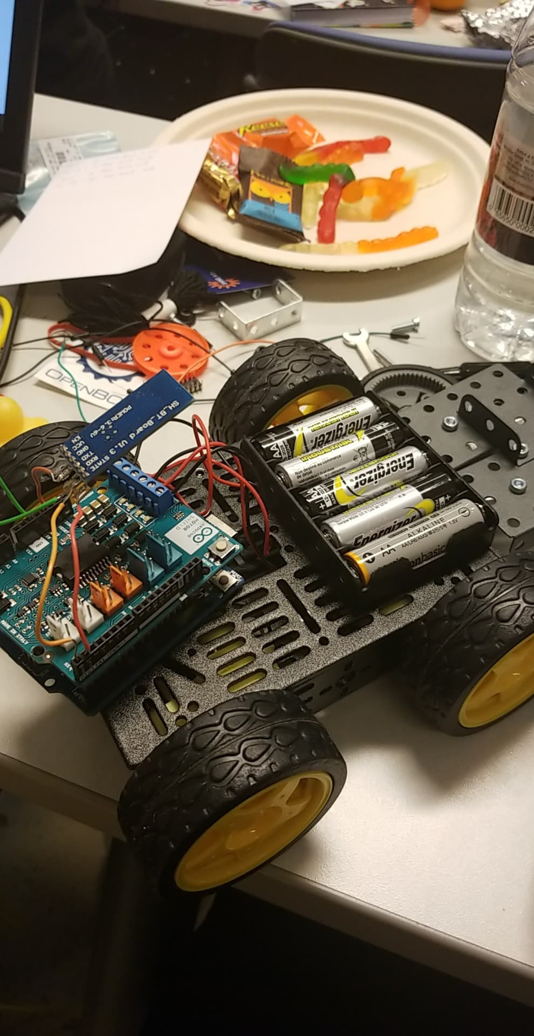

**Trouble With The Arduino; Should We Swith To The Teensy…?**

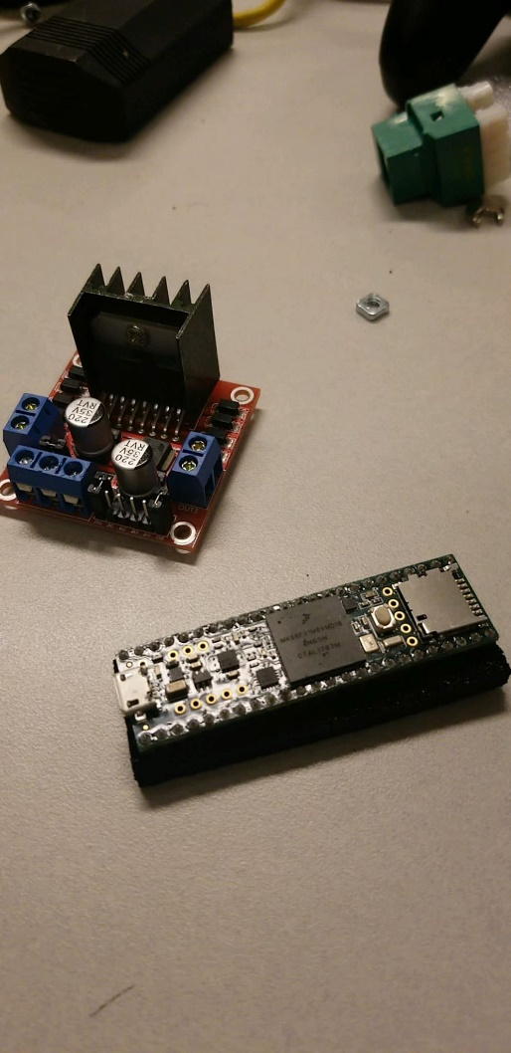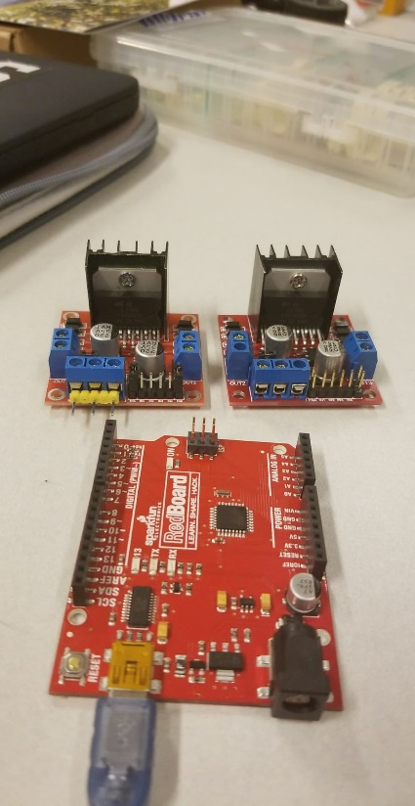

**Sir Quacksalot Helps Us Fix The Arduino!**

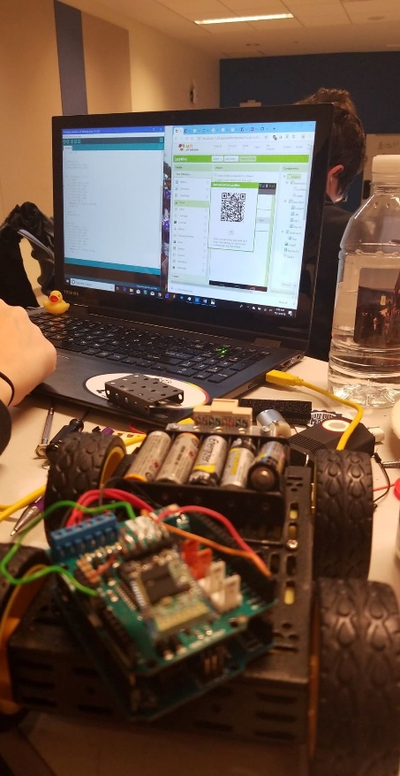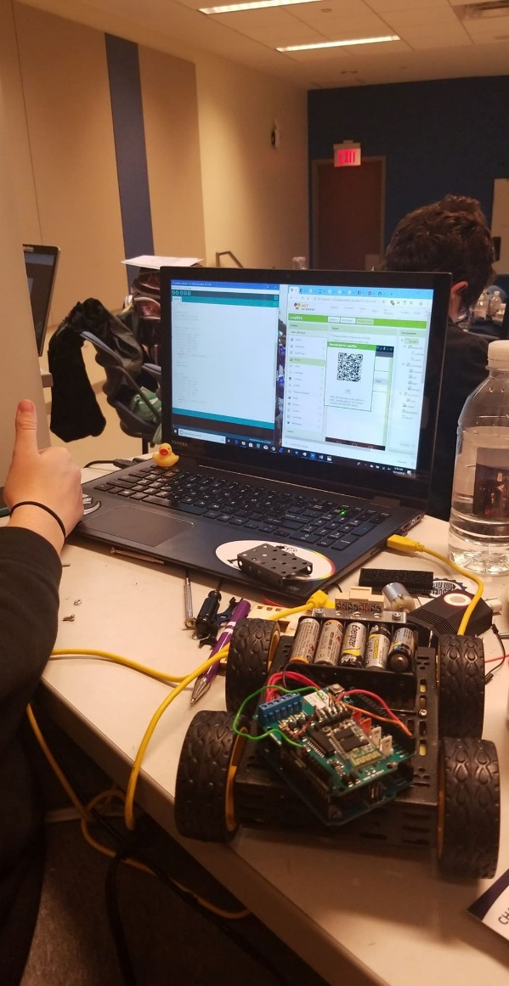

**Choosing A Controller….**

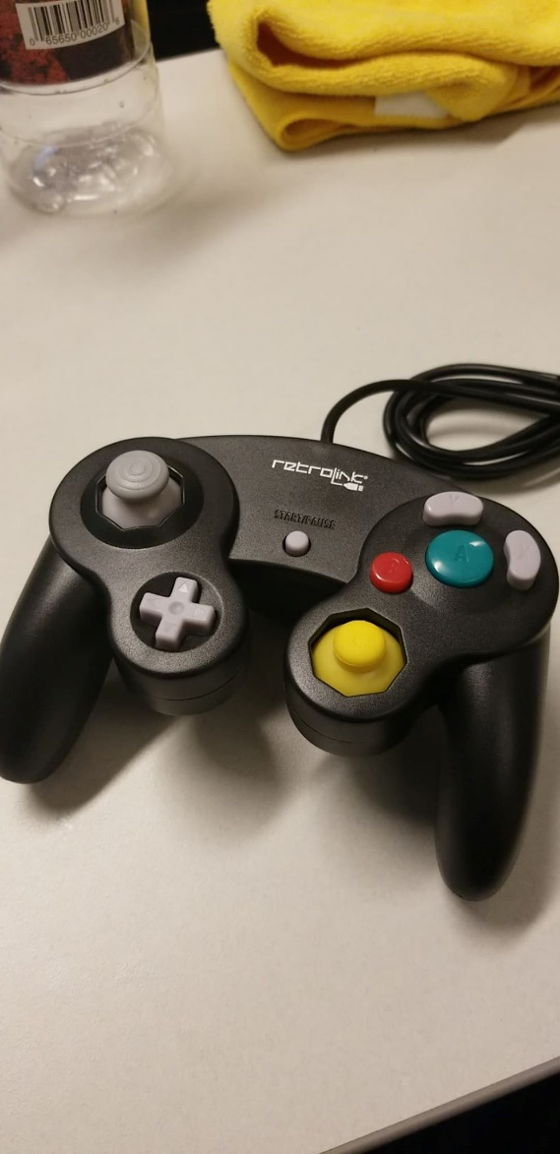

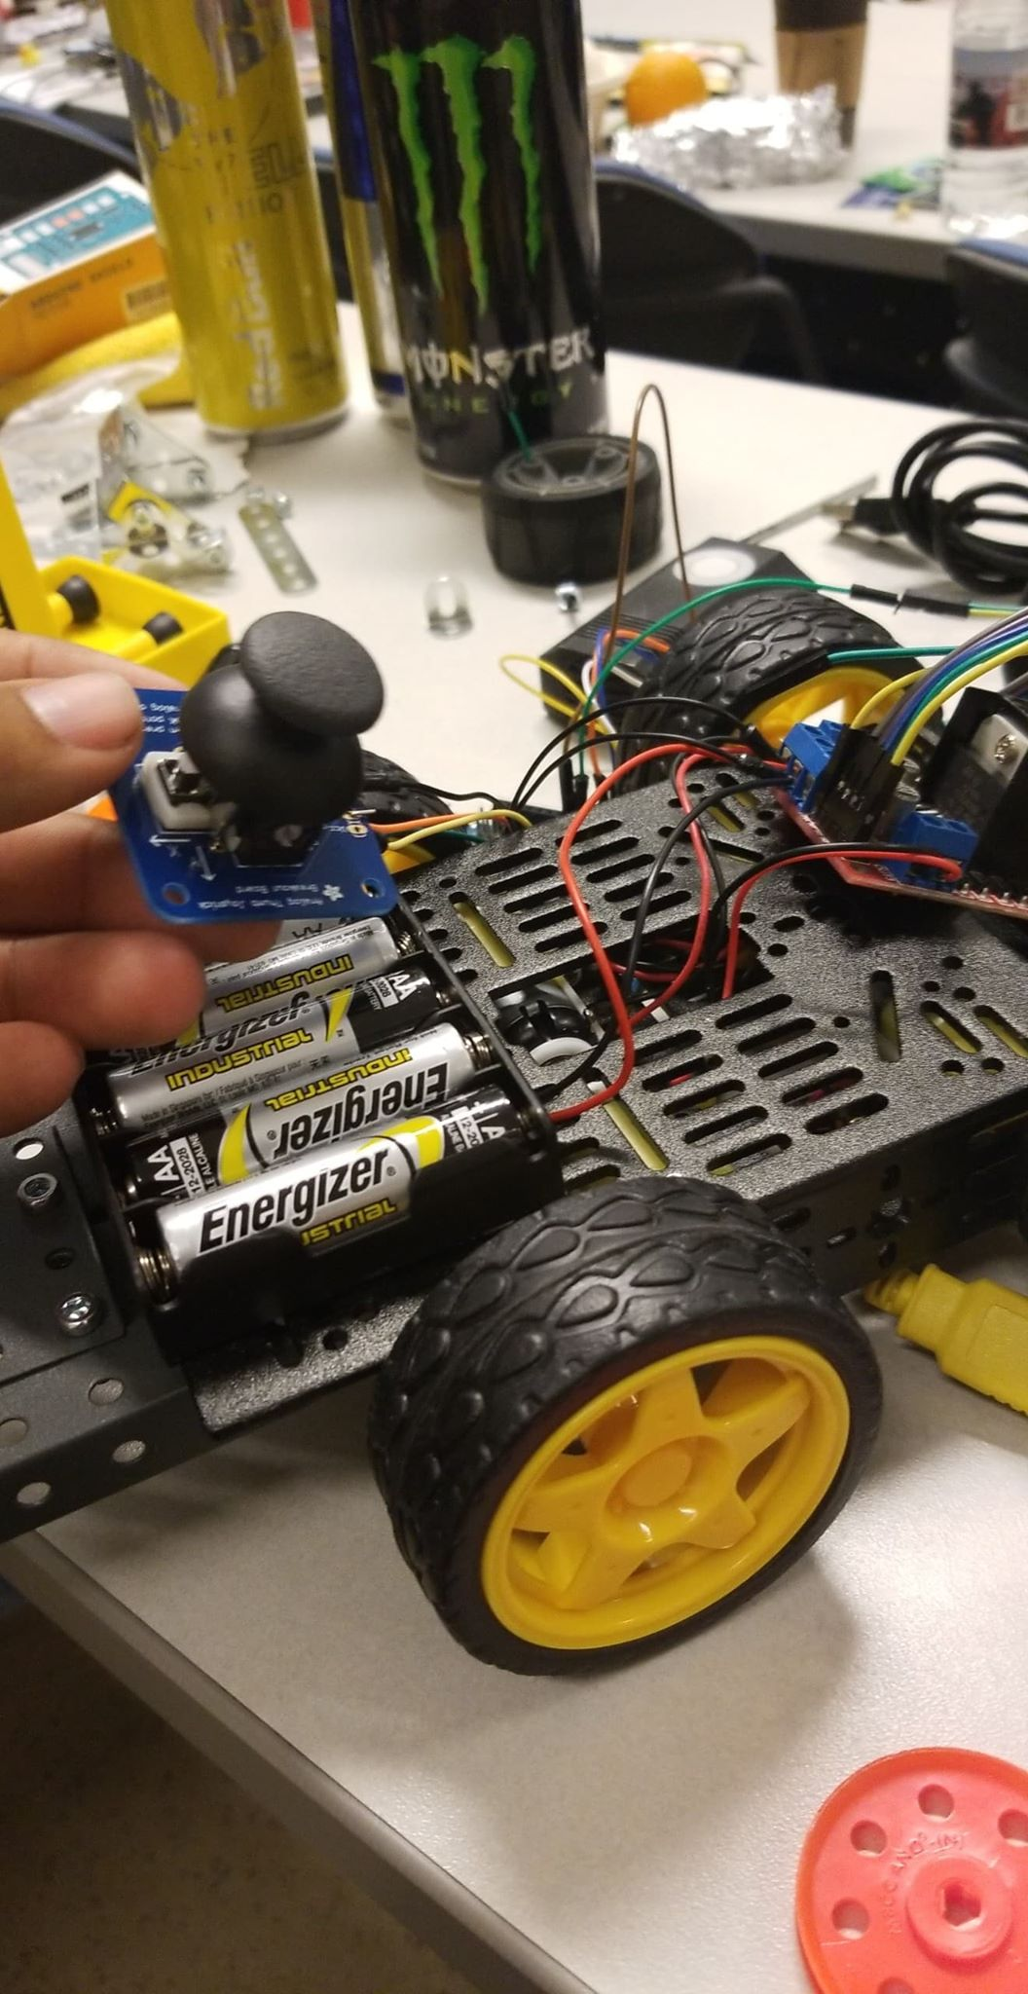

**Realizing The Controller Libraries Don’t Work and Using MITAppInventor Instead…..**

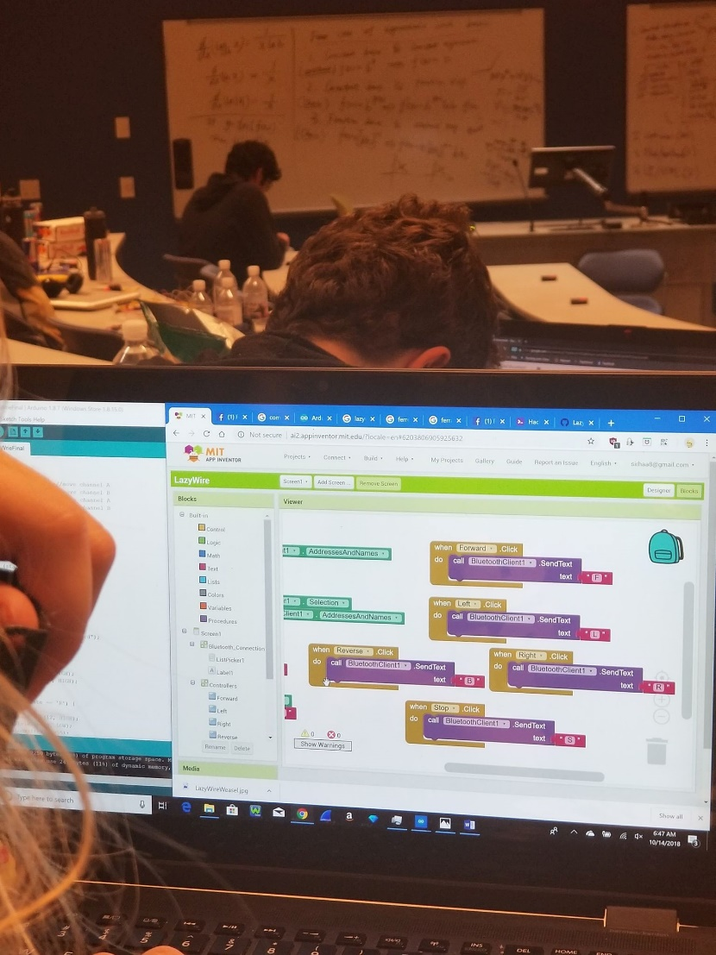

**The Controller App’s Final Form…**

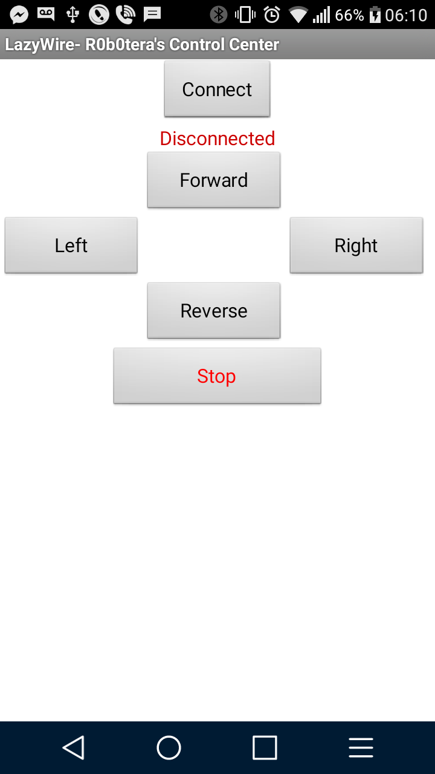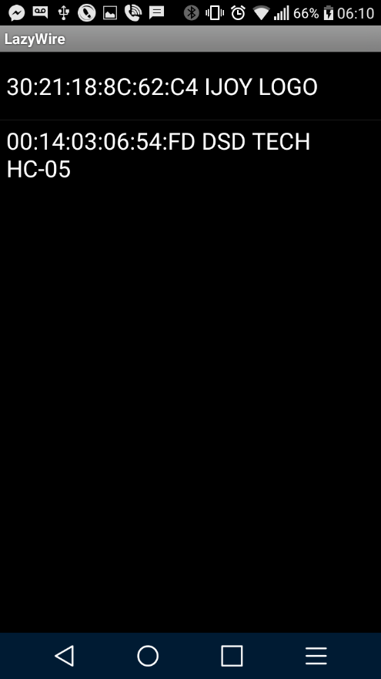

**The Success Programmers Dream of (Featuring The Sleepy Programmer)**

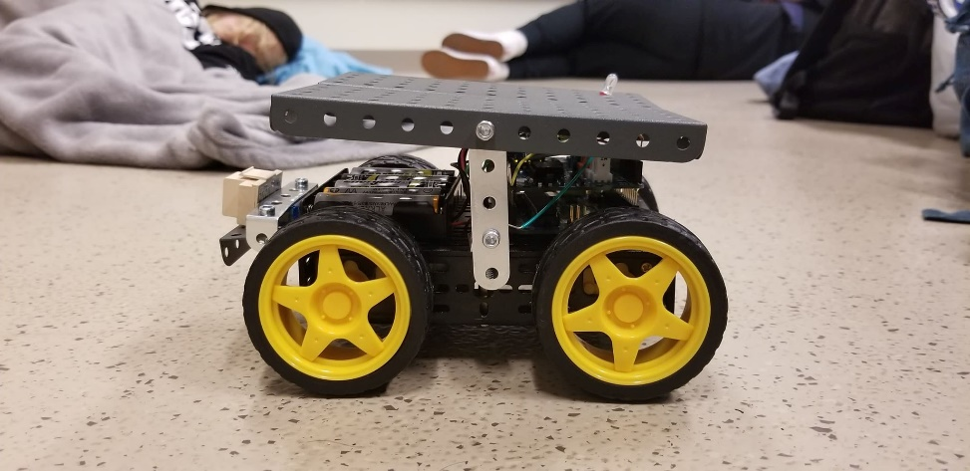

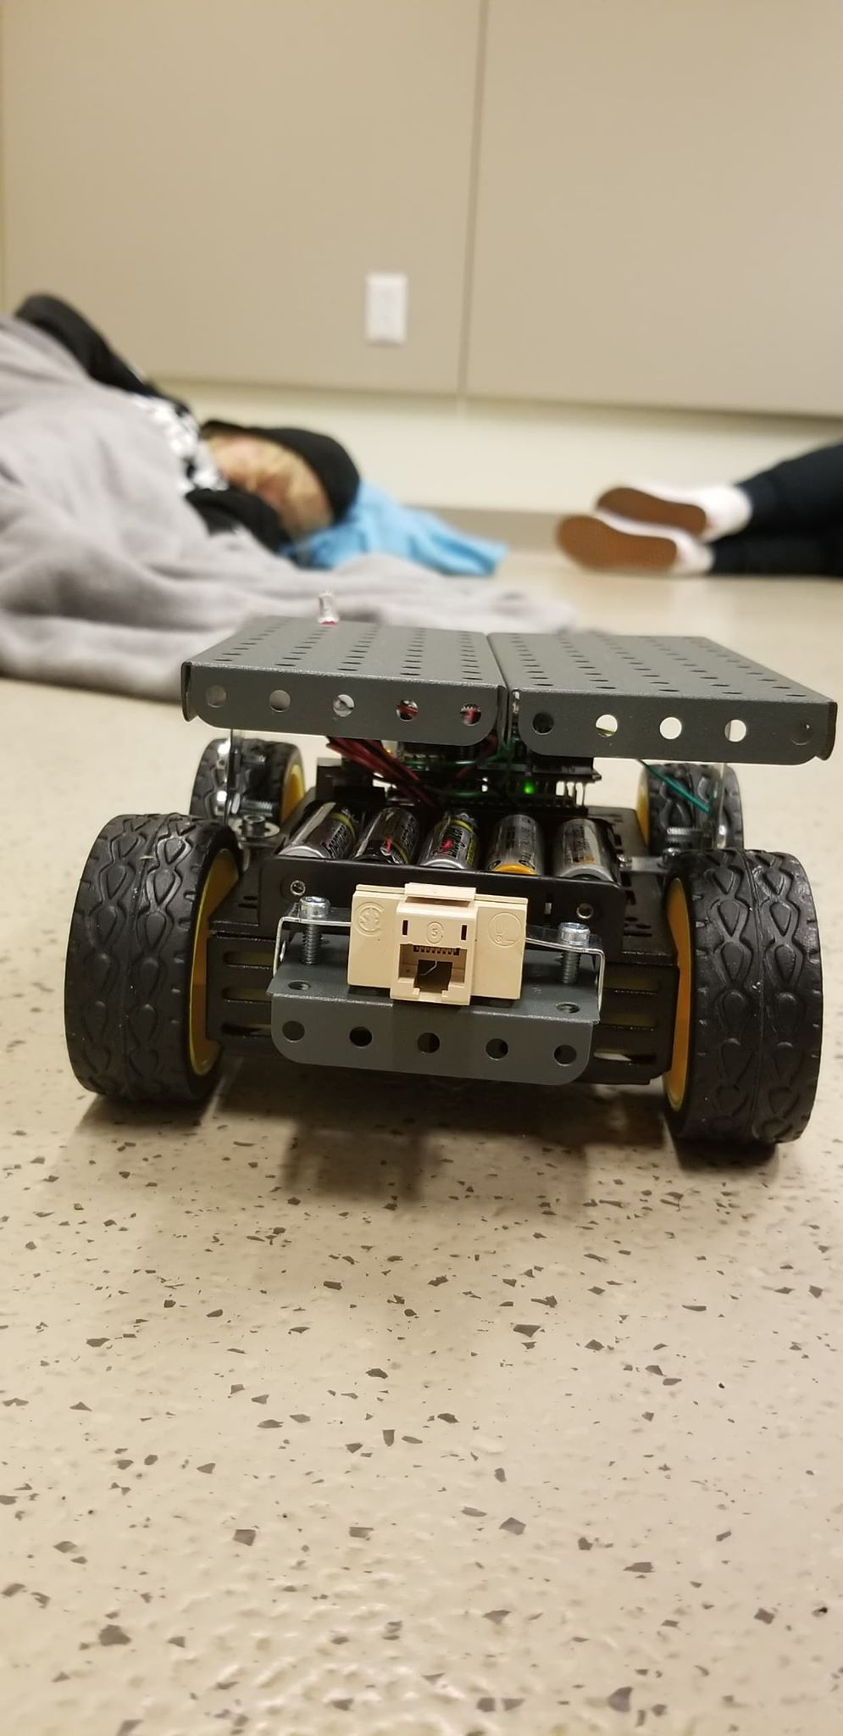

**On the date of October 14, 2018, we welcomed R0b0tera into the world, hoping that she will one day change it. This has been the story of her birth and creation, we hope you stick around to see the changes she brings to the engineering and networking worlds.**